UNITED STATES
SECURITIES AND EXCHANGE COMMISSION
WASHINGTON, D.C. 20549

FORM 8-K

CURRENT REPORT
Pursuant to Section 13 or 15(d)
of the Securities Exchange Act of 1934

Date of Report (Date of earliest event reported): April 24, 2026

REED’S, INC.
(Exact name of Registrant as Specified in Its Charter)

Delaware |  | 001-32501 |  | 35-2177773
(State or Other Jurisdiction  of Incorporation) |  | (Commission  File Number) |  | (I.R.S. Employer  Identification No.)
501 Merritt 7 PH  Norwalk, Connecticut |  |  |  | 06851
(Address of Principal Executive Offices) |  |  |  | (Zip Code)

Registrant’s Telephone Number, Including Area Code: (800) 997-3337

Not Applicable
(Former Name or Former Address, if Changed Since Last Report)

Check the appropriate box below if the Form 8-K filing is intended to simultaneously satisfy the filing obligation of the registrant under any of the following provisions:

☐ | Written communications pursuant to Rule 425 under the Securities Act (17 CFR 230.425)
☐ | Soliciting material pursuant to Rule 14a-12 under the Exchange Act (17 CFR 240.14a-12)
☐ | Pre-commencement communications pursuant to Rule 14d-2(b) under the Exchange Act (17 CFR 240.14d-2(b))
☐ | Pre-commencement communications pursuant to Rule 13e-4(c) under the Exchange Act (17 CFR 240.13e-4(c))

Securities registered pursuant to Section 12(b) of the Act:

Title of each class |  | Trading Symbol(s)* |  | Name of each exchange on which registered
Common stock, $0.0001 par value per share |  | REED |  | NYSE American LLC

Indicate by check mark whether the registrant is an emerging growth company as defined in Rule 405 of the Securities Act of 1933 (§ 230.405 of this chapter) or Rule 12b-2 of the Securities Exchange Act of 1934 (§ 240.12b-2 of this chapter).

Emerging growth company ☐

If an emerging growth company, indicate by check mark if the registrant has elected not to use the extended transition period for complying with any new or revised financial accounting standards provided pursuant to Section 13(a) of the Exchange Act. ☐

Item 5.02 | Departure of Directors or Certain Officers; Election of Directors; Appointment of Certain Officers; Compensatory Arrangements of Certain Officers.

On April 24, 2026, Reed’s, Inc. (the “Company”) announced the appointment of Damian Warshall as the Company’s Chief Operating Officer, effective April 27, 2026, assuming the role from Neal M. Cohane, who will continue to serve as the Company’s interim Chief Executive Officer.

Mr. Warshall, 43, most recently served as Chief Operating Officer of Pittston Co-Packers from April 2025 to April 2026. Prior to that, he served as Vice President of Operations of Munk Pack, from June 2024 to March 2025. Previously, Mr. Warshall served as the Vice President of Operations for the Company, from October 2020 to May 2024. Mr. Warshall earned a Master of Business Administration from the University of Virginia and a Bachelor of Science in Business Administration in Accounting and Finance from Georgetown University.

In connection with Mr. Warshall’s appointment, the Company entered into an Offer of Employment with Mr. Warshall (the “Warshall Offer Letter”), pursuant to which Mr. Warshall will receive an initial annual base salary of $300,000, less applicable withholdings, and will be eligible for an initial annual target bonus of up to 80% of his annual base salary. A copy of the Warshall Offer Letter is attached as Exhibit 10.1 to this Current Report on Form 8-K and is incorporated herein by reference. The foregoing description of the Warshall Offer Letter does not purport to be complete and is qualified in its entirety by reference to the full text of the Warshall Offer Letter.

Mr. Warshall is eligible to enter into the Company’s standard form of indemnification agreement.

There are no family relationships between Mr. Warshall and any director or executive officer of the Company, and Mr. Warshall is not a party to any transaction required to be disclosed pursuant to Item 404(a) of Regulation S-K.

Item 7.01 | Regulation FD Disclosure.

On April 24, 2026, the Company issued a press release announcing Mr. Warshall’s appointment. The press release is furnished as Exhibit 99.1 to this Current Report on Form 8-K and incorporated herein by reference.

The information contained in this Item 7.01 of this Current Report on Form 8-K, including Exhibit 99.1 attached hereto, is furnished pursuant to Item 7.01 of Form 8-K and shall not be deemed “filed” for purposes of Section 18 of the Securities Exchange Act of 1934, as amended, or subject to the liabilities of that section or Sections 11 and 12(a)(2) of the Securities Act of 1933, as amended. The information shall not be deemed incorporated by reference into any other filing with the Securities Exchange Commission made by the Company regardless of any general incorporation language in such filing, except as shall be expressly set forth by specific reference in such filing.

Item 9.01 | Financial Statements and Exhibits.

(d) Exhibits

Exhibit  Number |  | Description
10.1 |  | Offer of Employment, dated April 10, 2026, between the Company and Damian Warshall.
99.1 |  | Press Release, dated April 24, 2026.
104 |  | Cover Page Interactive Date File (embedded within the Inline XBRL document).

2

SIGNATURES

Pursuant to the requirements of the Securities Exchange Act of 1934, the registrant has duly caused this report to be signed on its behalf by the undersigned thereunto duly authorized.

 | Reed’s, Inc.
Date: April 24, 2026 | By: | /s/ Douglas W. McCurdy
 |  | Douglas W. McCurdy
 |  | Chief Financial Officer

3

Exhibit 10.1

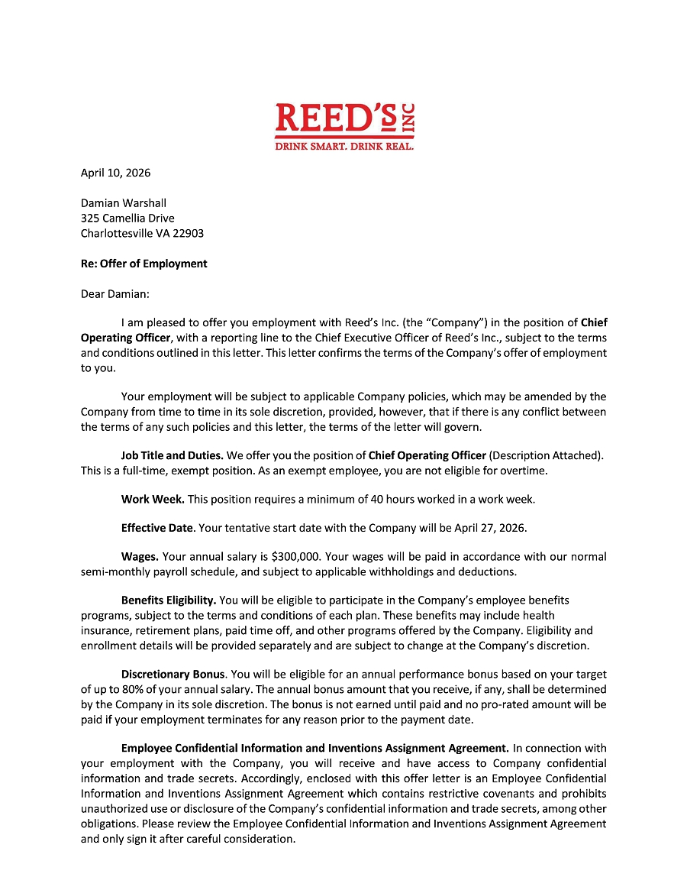

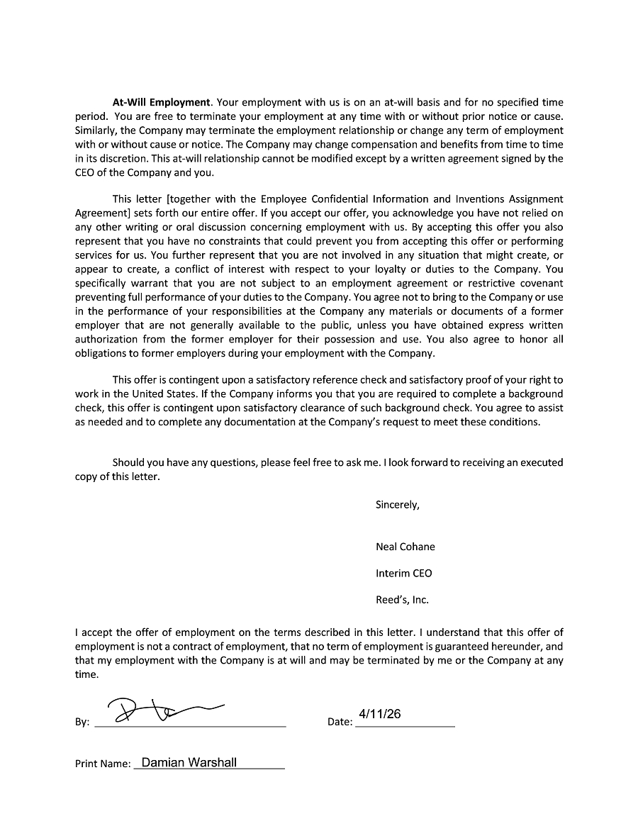

Exhibit 99.1



Reed’s Announces Appointment of Damian Warshall as Chief Operating Officer

NORWALK, CT, (April 24, 2026) — Reed’s, Inc. (NYSE American: REED) (“Reed’s” or the “Company”), owner of the nation’s leading portfolio of handcrafted, natural ginger beverages, today announced the appointment of Damian Warshall as Chief Operating Officer, effective April 27, 2026.

Mr. Warshall is a seasoned consumer packaged goods (CPG) operations executive with deep expertise in scaling beverage manufacturing operations, enhancing supply chain efficiency and driving profitable growth across complex organizations. Most recently, he served as Chief Operating Officer at Pittston Co-Packers, where he led the revitalization of a large-scale beverage manufacturing facility and secured a multi-million-dollar revenue pipeline. Prior to this, he served as Vice President of Operations at Munk Pack, leading production and commercialization initiatives, including a nationwide retail launch. Mr. Warshall is well known to Reed’s, having previously served as Vice President of Operations. He holds an M.B.A. from the University of Virginia’s Darden School of Business and a B.S.B.A. in Accounting and Finance from Georgetown University.

“Damian’s operational leadership and proven ability to build efficient, scalable manufacturing and supply chain systems position him well to enhance execution across our business operations,” said Neal Cohane, Interim Chief Executive Officer of Reed’s. “He brings a strong track record of driving operational discipline, improving cost structures and supporting profitable growth, which we believe will be critical as we continue to optimize our business. We believe his experience will be instrumental in strengthening our operational foundation, improving margins and creating long-term value for our shareholders.”

Mr. Warshall added, “I’m excited to return to Reed’s as Chief Operating Officer and to work alongside the team to further strengthen our operational capabilities. Our priorities will focus on driving efficiencies across our manufacturing and logistics network, increasing throughput, and enhancing execution with our partners. Delivering more consistent, scalable performance will be a central focus in 2026 and beyond as we continue to build a stronger, more efficient operating platform.”

About Reed’s, Inc.

Reed’s is an innovative company and category leader that provides the world with high quality, premium and better-for-you beverages. Established in 1989, Reed’s is a leader in craft beverages under the Reed’s®, Virgil’s® and Flying Cauldron® brand names. The Company’s beverages are now sold in over 32,000 stores nationwide.

Forward-Looking Safe Harbor Statement

This press release contains forward-looking statements which are subject to the safe harbor provisions of the Private Securities Litigation Reform Act of 1995, as amended. Forward-looking statements are statements that are not historical facts, reflect management’s expectations as of the date of this press release, and involve certain risks and uncertainties. Forward-looking statements include, but are not limited to, statements herein with respect to implied or express statements regarding the anticipated contributions and impact of the executive appointment, and the Company’s expectations regarding its business strategies and plans and its ability to create long-term value for our shareholders. These forward-looking statements are based on our current expectations and may differ materially from actual results due to a variety of factors, including the risk factors and uncertainties described under the caption “Risk Factors” in the Company’s filings with the Securities and Exchange Commission, including its Annual Report on Form 10-K for the year ended December 31, 2025, filed with the Securities and Exchange Commission on March 25, 2026. The forward-looking statements in this press release are based on information available to the Company as of the date hereof, and the Company disclaims any obligation to update any forward-looking statements, except as required by law.

Investor Relations Contact

Sean Mansouri, CFA or Aaron D’Souza
Elevate IR
ir@reedsinc.com
(720) 330-2829

